Solar powered Mobile voiceover studio in cargo trailer

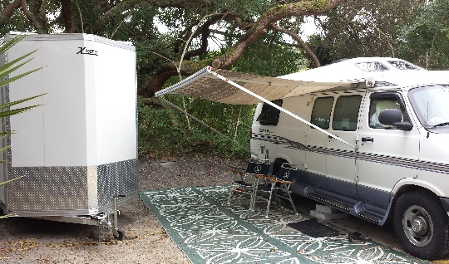

Custom built voiceover booth using “room within a room” construction. The booth is elevated about 5 inches off the floor and has separation from all walls.

The door is 5.5 inches thick.

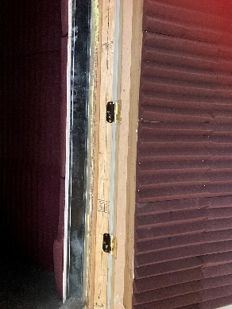

The booth walls are Quietrock, which is a sound reducing drywall.

(Scroll down 1 page for more photos.)

**Construction details:**

Resiliently mounted ceiling and wall:

Kinetics Resilient IsoMax sound isolation clips (please request additional info via PDF):

Mineral fiber insulation for fire stopping

Resilient non-hardening fire-rated sealant

Solid core booth door with Homasote on exterior, angled 1x6 framing attached on inside of door with insulation inside it with Quietrock on inside frame.

Isolation walls: 2x3 stud with ½ inch of Homosote 440 board (on top of each other) on the exterior side and one layer of Homosote 440 board on the interior side of the stud with mineral wood insulation batts inside the stud (between the 2 layers of Quietrock).

Booth is constructed of 2x6 (actually 2x5.5) stud and ½ inch Quietrock on both sides of stud with mineral wood insulation batts inside the stud (between the 2 layers of Quietrock)

1 ½ inch thick Styrofoam insulation inserted between trailer exterior siding (on side walls and inside roof) and interior plywood. Homosote 440 on walls and ceiling using mostly special glue and some fasteners.

2 layers of rubber padding under the “floating” booth as far as the isolation walls and 4 foot side sections of exterior walls.

2x6 framing for floor and ceiling panels

The booth is lined with commercial grade sound dampening acoustic foam.

There is one roof mounted solar panel for working away from an electric source.

Two batteries for the solar (only one is pictured)

Cable pass-through for all cables and cords to access solar power.

Roof vent in main part of trailer.

Lots of storage in front of trailer

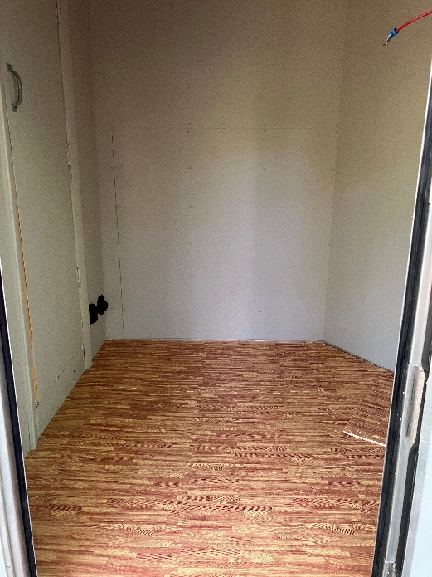

and storage in the rear as well.

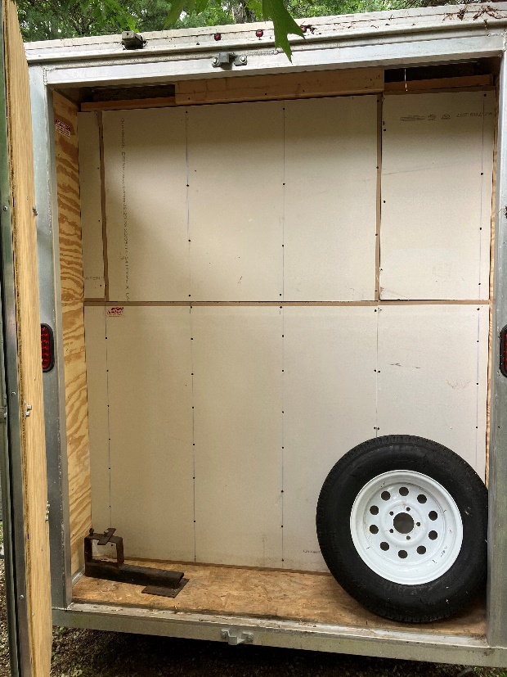

Spare tire included.

**$6000**

Please request samples of audio recorded in the booth.

Testimonials:

*“Karen Salus is taking the portable voiceover studio concept to a whole new level. Most people should not even attempt to do what she is doing. However, because Karen is genuinely concerned about providing the best audio possible and doing whatever it takes (including sparing no expense) to ensure that she can deliver a great product. You’ve got to admire her for figuring out a viable way to live the adventurous life she wants to live and still deliver great sounding audio to her clients.”*

*Dan Friedman – Audio Engineer and author of Sound Advice – Voiceover From an Audio Engineer’s Perspective*

*“At ProComm Voices, maintaining consistent high quality audio for our clients is a top priority. Working with Karen over the years has always been a joy, not only because of her immense talent, but also because we know we never have to worry about audio quality. Whether recording from her home studio, or one of her mobile set ups, we know we can always count on consistent, pristine sound. In fact, listening back, I’d be hard pressed to tell which sessions were recorded on the road, and which were from the home studio.”*

Chris Porter – Operations Manager, ProComm Voices

*“We have worked with Karen for many years now and the quality from her mobile booth was great. We’d happily record with her for commercial and broadcast projects as we know we can always count on great sound from her.”*

Paul Bridge – Project Support, Voiceovers Limited, UK